Conceptual Framework



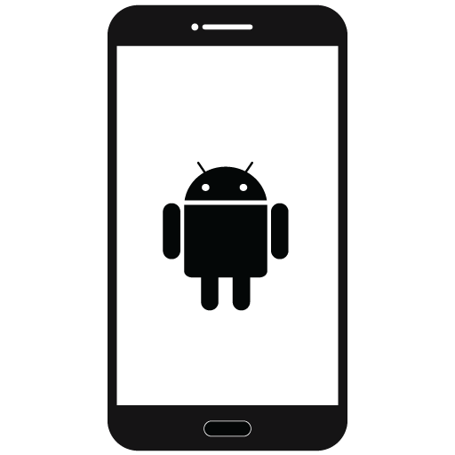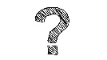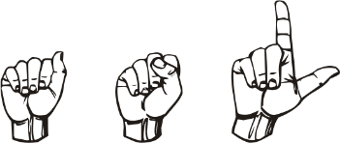

Communication Barrier exist to between a person with no knowledge of sign language and a deaf or mute person.

Mobile Application that translate speech to sign language to overcome communication barrier.